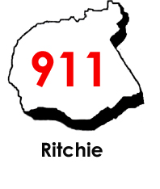

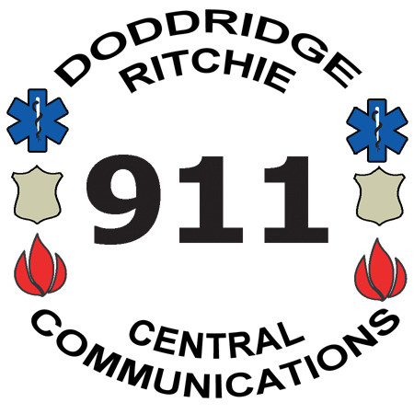
Central Communications, Inc.
4317 Lamberton Road, P.O. Box 516
Pennsboro, WV 26415
Phone: 304-659-3770 Fax: 304-659-3772
Mapping & Addressing: 304-659-2979
www.centrale911.com
Executive Director
Eric E. Ashcraft

Board of Directors
Samuel Rogers
Clinton Means
Shawn Glaspell
Steve Ritter

Recording Request – Law Enforcement Use

Central Communications Inc., (CCI) will provide radio and/or telephone recordings to law enforcement agencies, for investigative and/or court purposes. Once the information is turned over to law enforcement it is the sole responsibility of the requesting agency and/or officer to ensure that the information is used only for law enforcement purposes. CCI will not be responsible for this information once it has left the CCI facility. The following recording(s) are being provided by CCI for law enforcement or court purposes only.
Requesting agency agrees to provide a replacement CD or if they wish to use a cassette tape, provide a tape to CCI for the recording.

Call Number(s) : | Subject :

Date of Incident(s) : | Time of Incident(s):

Requesting Agency :

Requesting Officer :

Reason for Issue :

Text of call details? Audio recording?

911 Call Phone Traffic Radio Traffic

Recorded by:________________________________________________ Date:_____________
Signature

Released by authority of:

CCI Officer: _________________________________________________ Date:_____________
Signature

Received by:
L.E. Officer: _________________________________________________ Date:____________ Signature

Ver. 13 07/256/23

